Project Design Phase-II
Data Flow Diagram & User Stories

Date | 25 September 2026
Team ID | SWTID-2026-8948
Project Name | AI FAQ Assistant
Maximum Marks | 4 Marks

Data Flow Diagrams
The Data Flow Diagram (DFD) of the AI FAQ Assistant represents how data moves through the system. It shows how users interact with the application, how requests are processed by the backend, how FAQ and user data are stored in MongoDB, and how AI-related requests are processed using Google Gemini AI.
The main data flows include:
- User → API: User registration, login, FAQ requests, search queries, and AI questions.
- API → Authentication: User credentials are verified and JWT authentication is handled.
- API → MongoDB: User and FAQ information is stored and retrieved.
- API → Gemini AI: Questions and FAQ-generation requests are sent to the AI service.
- Gemini AI → API: AI-generated answers or FAQ content are returned.
- API → User: The processed result is returned to the user.

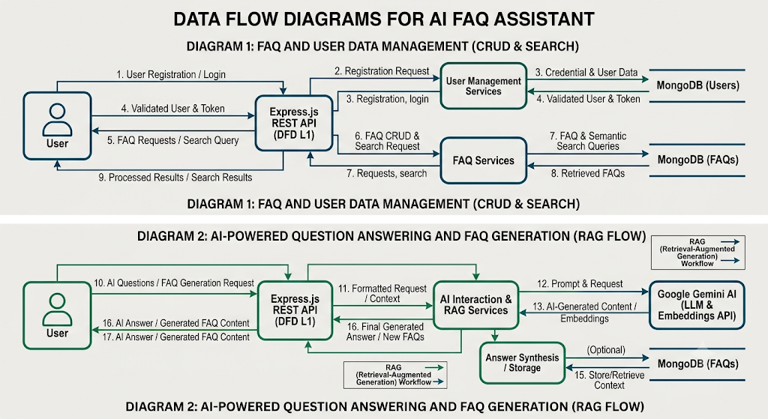

User stories

User Type | Functional Requirement (Epic) | User Story Number | User Story / Task | Acceptance Criteria | Priority | Release
Authenticated User | Registration | USN-1 | As a user, I can register for the application by providing my required details. | User account is created successfully and user data is stored securely. | High | Sprint-1
Authenticated User | Login | USN-2 | As a user, I can log into the application using my registered credentials. | Valid credentials allow the user to log in successfully. | High | Sprint-1
Authenticated User | Authentication | USN-3 | As a user, I can access protected resources using secure authentication. | A valid JWT token is required to access protected resources. | High | Sprint-1
Authenticated User | Profile | USN-4 | As a user, I can access my profile information after authentication. | Authenticated user can retrieve their profile information. | Medium | Sprint-1
Authenticated User | FAQ Management | USN-5 | As a user, I can create a new FAQ. | Valid FAQ details are stored successfully in the database. | High | Sprint-2
Authenticated User | FAQ Management | USN-6 | As a user, I can view available FAQs. | Existing FAQ records are displayed successfully. | High | Sprint-2
Authenticated User | FAQ Management | USN-7 | As a user, I can update an existing FAQ. | The selected FAQ is updated with the new information. | High | Sprint-2
Authenticated User | FAQ Management | USN-8 | As a user, I can delete an existing FAQ. | The selected FAQ is removed successfully. | High | Sprint-2
FAQ User | Search | USN-9 | As a user, I can search for relevant FAQs using a query. | Relevant FAQ results are returned for the search query. | High | Sprint-3
FAQ User | Category Management | USN-10 | As a user, I can organize and access FAQs by category. | FAQs can be associated with and retrieved using categories. | Medium | Sprint-3
FAQ User | AI Question Answering | USN-11 | As a user, I can ask questions and receive AI-generated answers. | The system sends the question to the AI service and returns a relevant answer. | High | Sprint-4
FAQ User | AI FAQ Generation | USN-12 | As a user, I can generate FAQ content using AI. | The system generates FAQ content based on the provided input. | High | Sprint-4
System User | Validation | USN-13 | As a system, I can validate user and FAQ data before processing it. | Invalid or incomplete data is rejected with an appropriate error. | High | Sprint-4
System User | Error Handling | USN-14 | As a system, I can handle API errors centrally. | Appropriate error responses are returned when an error occurs. | Medium | Sprint-4

